**Bug ID:** BUG-001

**Title:** The ADD TO CART btn to some products isn't clickable to problem_user

**Description**: when I login with username “problem_user” and

click on ADD TO CART button to some products doesn't work

**Steps:**

1- open url : "<https://www.saucedemo.com/v1/>"

2- enter "problem_user" in username field

3- enter "secret_sauce" in password field

4- click on login btn

5-click on ADD TO CART btn in products page

**Expected Result**: the product will be added in cart page,

the cart icon counter increases by 1,

the button label should update from 'ADD TO CART' to 'REMOVE'.

**Actual Result:** the ADD TO CART btn in products page to some products doesn`t work

**Priority**: high

**Severity**: high  
---

**Screenshot/video:**

**<https://drive.google.com/file/d/1EiCsNtnsxAL7NFfnP0_LfBpXvtNDtpUq/view?usp=sharing>**

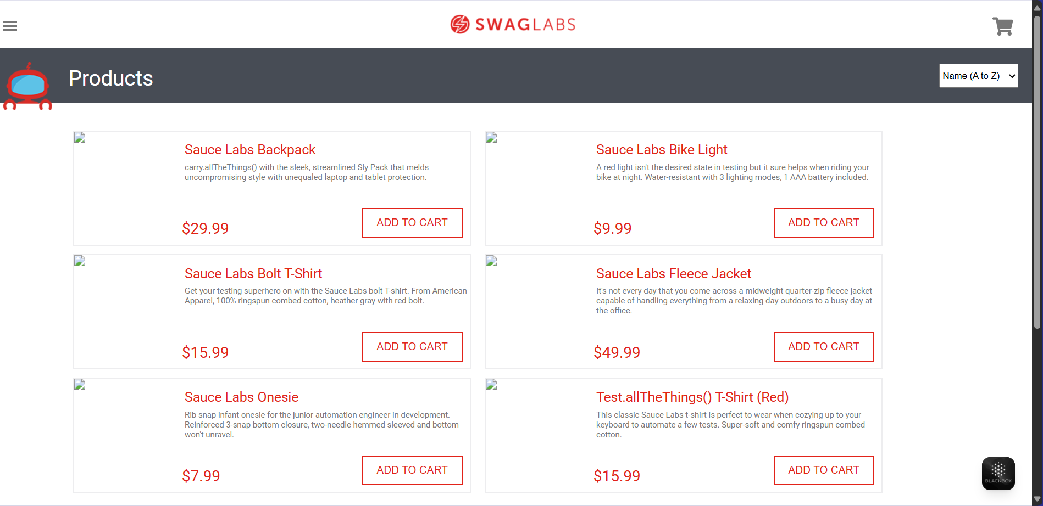

**Bug ID:** BUG-002

**Title:** The REMOVE btn isn't clickable to problem_user

**Description**: when I login with username “problem_user” and add products to cart then try to move it by click on REMOVE btn in products page it doesn't work.

**Steps:**

1- open url : "<https://www.saucedemo.com/v1/>"

2- enter "standard_user" in username field

3- enter "secret_sauce" in password field

4- click on login btn

5- click on ADD TO CART btn in products page

6- click on REMOVE btn in products page

**Expected Result**: the product will be removed from cart page,

the cart icon counter decrease by 1,

the button label should update from 'REMOVE' to 'ADD TO CART'.

**Actual Result:** the REMOVE btn in products page doesn't work

**Priority**: high

**Severity**: high  
---

**Screenshot/video:**

**<https://drive.google.com/file/d/1vFFuYwx5nwr9kpOfK0VXO_iqPBzrGtJS/view?usp=sharing>**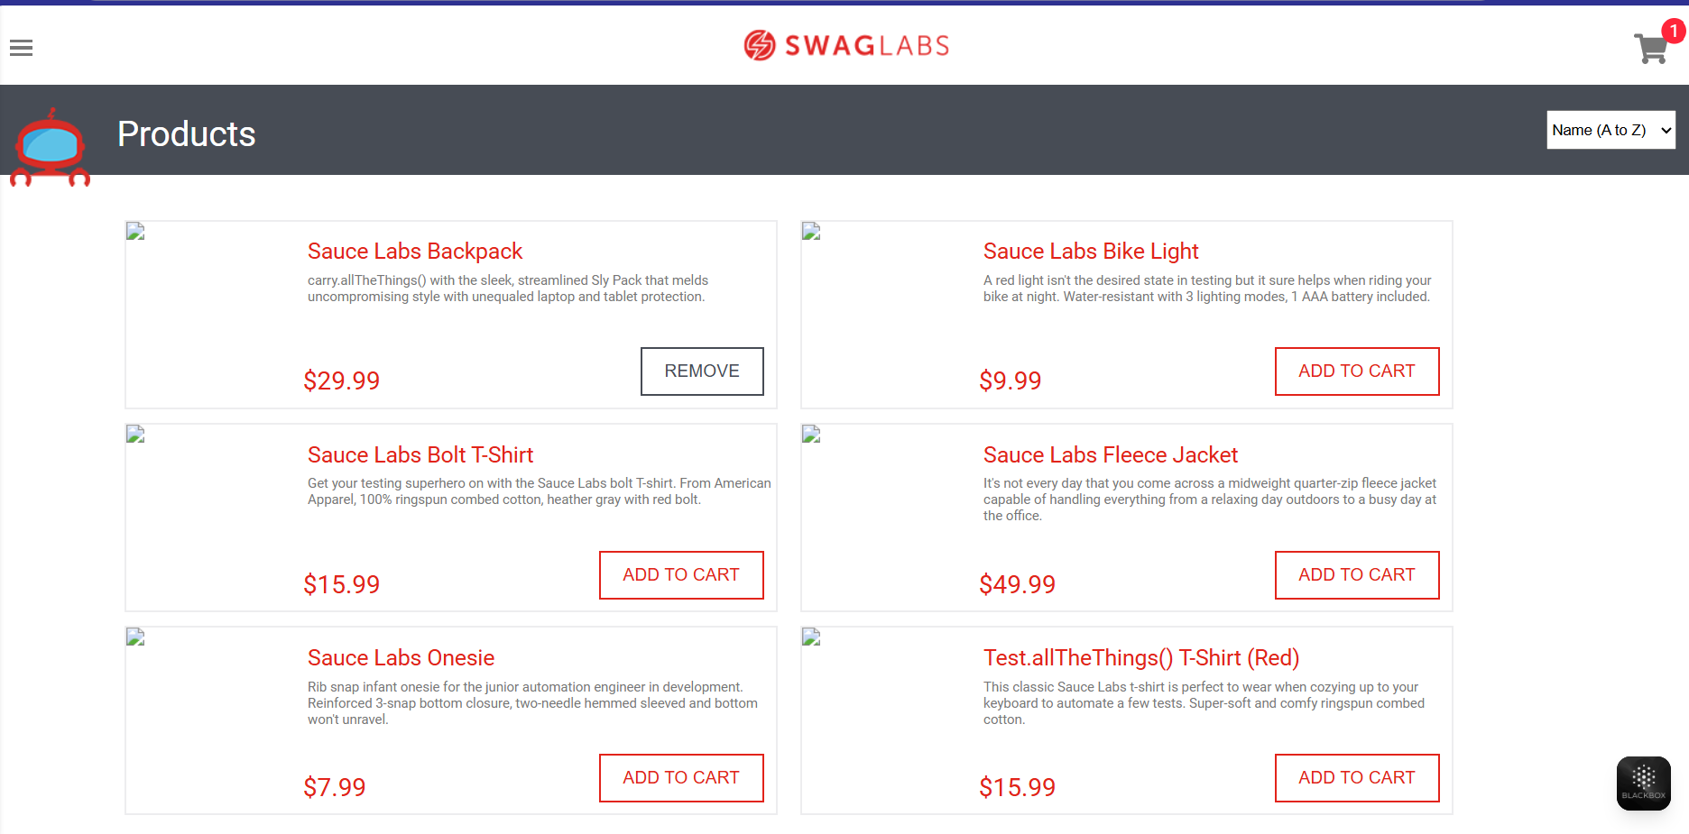

**Bug ID:** BUG-003

**Title:** There is no quantity field in product details page

**Description**: in product details page , i want to control of the quantity to the product but the quantity field is not available.

**Steps:**

1- open url :"<https://www.saucedemo.com/v1/>"

2- enter "standard_user" in username field

3- enter "secret_sauce" in password field

4- click on login btn

5-click on a product in products page

6- make sure that there is quantity field beside the product in product details page

**Expected Result**: the quantity field should be visible and selectable.

**Actual Result:** the quantity field is not available so I can't control of quantity.

**Priority**: Meduim

**Severity**: Meduim  
---

**Screenshot/video:**

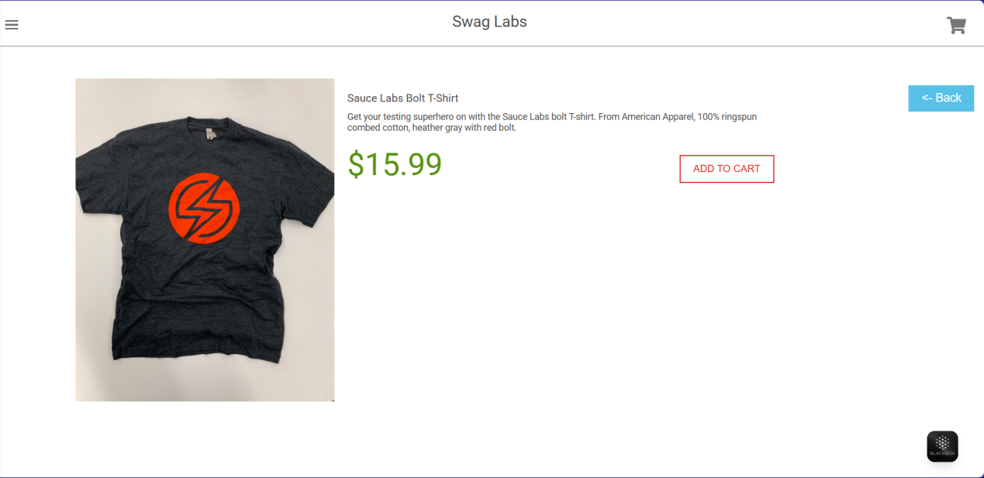

**Bug ID:** BUG-004

**Title:**  The Cart button state not updating consistently across pages after adding product from Product Details

**Description:** When I adds a product to the cart from the **Product Details** page, the cart button does not update correctly across the products page, The button remains as **ADD TO CART** on the Products page instead of changing to **REMOVE**, causing confusion for the user.

**Steps:**

1- open url : "<https://www.saucedemo.com/v1/>"

2- enter "standard_user" in username field

3- enter "secret_sauce" in password field

4- click on login btn

5- click on a product in products page

6- click on ADD TO CART btn in product details page

7- go back to the Products page to check the state of btn to same product

8- go to cart page to check the state of btn

**Expected Result:** The button on the Product Details page will changes to Remove,

The button on the Products page also updates to Remove,

The product appears in the Cart page with the btn labeled Remove.

**Actual Result:** The button state does not update in products page remain labeled **ADD TO CART** even after the product has been added in product details page.

**Priority**: Meduim

**Severity**: low  
---

**Screenshot/video:**

**<https://drive.google.com/file/d/1PxeZK9sQ9-36xKwmSZvdr8Xk9LpGqLi-/view?usp=sharing>**

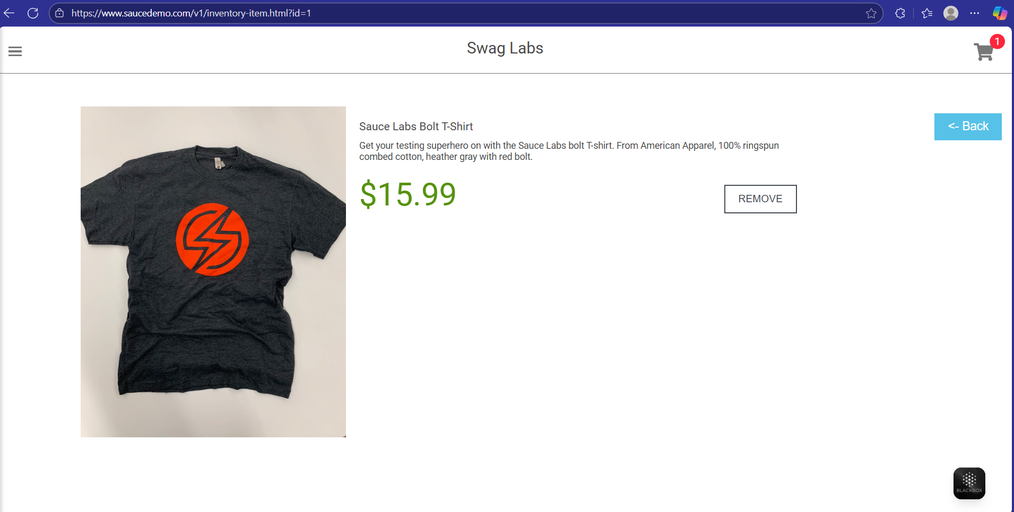

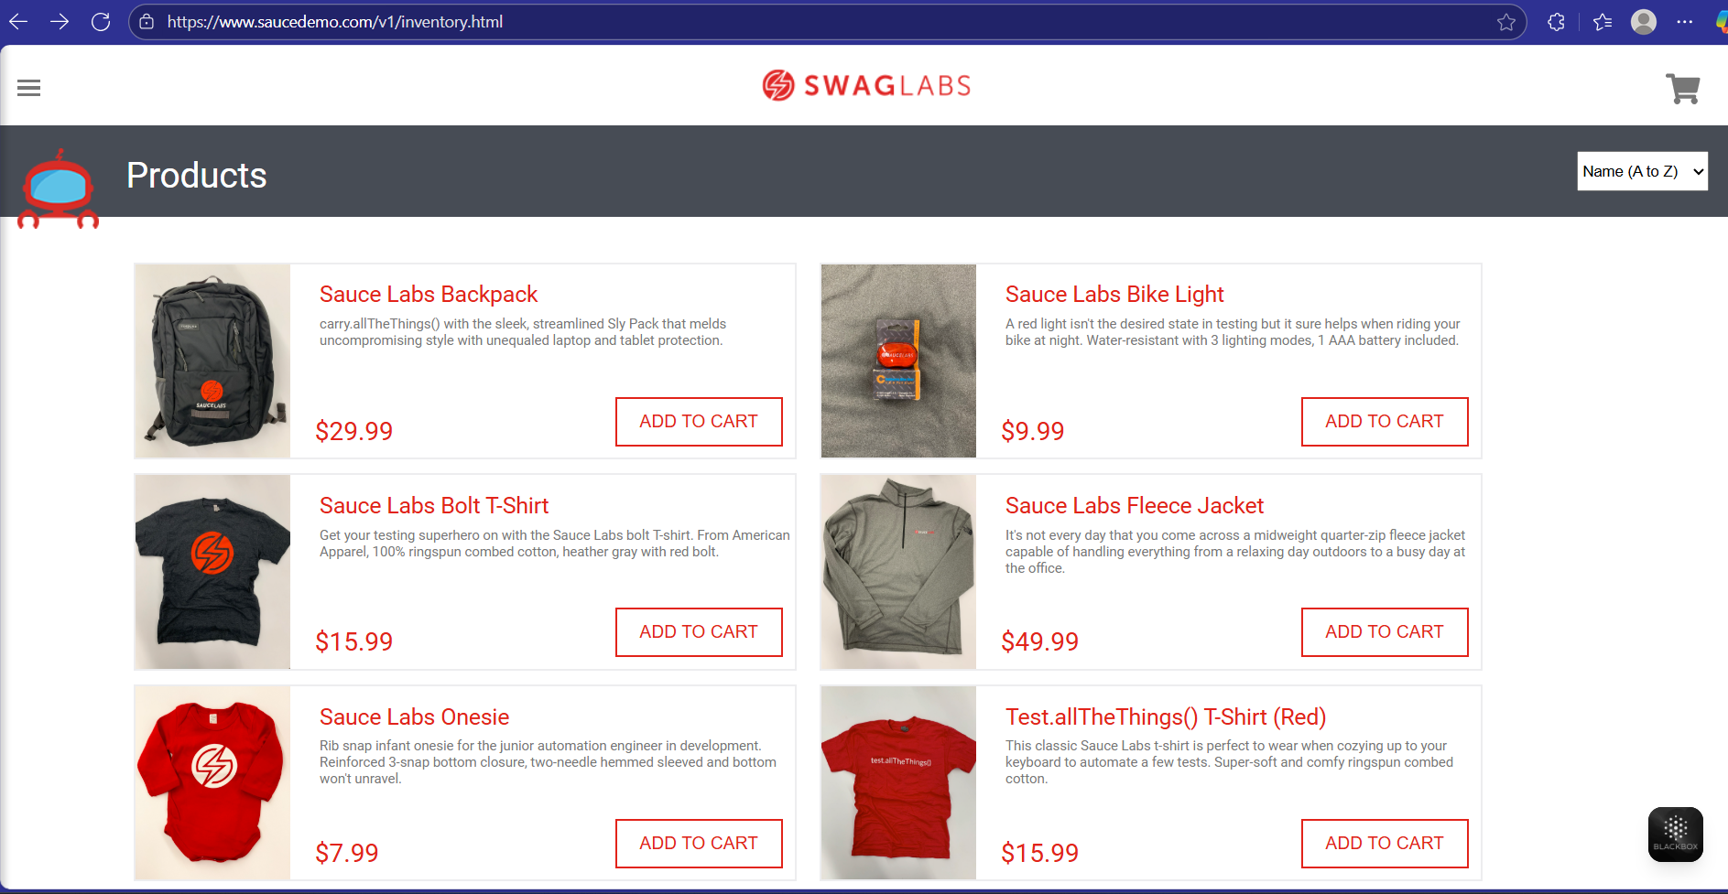

**Bug ID:** BUG-005

**Title:** The Cart button state not updating correctly after removing a product from Product Details page

**Description**: When I remove a product from the **Product Details** page by clicking the **REMOVE** button, the button state does not update correctly across the products page, The button remains labeled **REMOVE** instead of changing back to **ADD TO CART** on the Products page so causing confusion for the user.

**Steps:**

1- open url : "<https://www.saucedemo.com/v1/>"

2- enter "standard_user" in username field

3- enter "secret_sauce" in password field

4- click on login btn

5- click on ADD TO CART btn in products page

6- click on a product in products page

7- click on REMOVE btn in product details page

8- go back to the Products page to check the state of btn to same product

**Expected Result:** The button on the Product Details page will change to Add To cart,

The button on the Products page also updates to Add to cart,

The Cart page should not display the product anymore.

**Actual Result:** The button state does not update in products page remain labeled **REMOVE** even though the product is removed in product details page.

**Priority**: Meduim

**Severity**: low  
---

**Screenshot/video:**

**<https://drive.google.com/file/d/1yIebTuU7l0xhrK2G9wi6iIm1BFFwT81r/view?usp=sharing>**

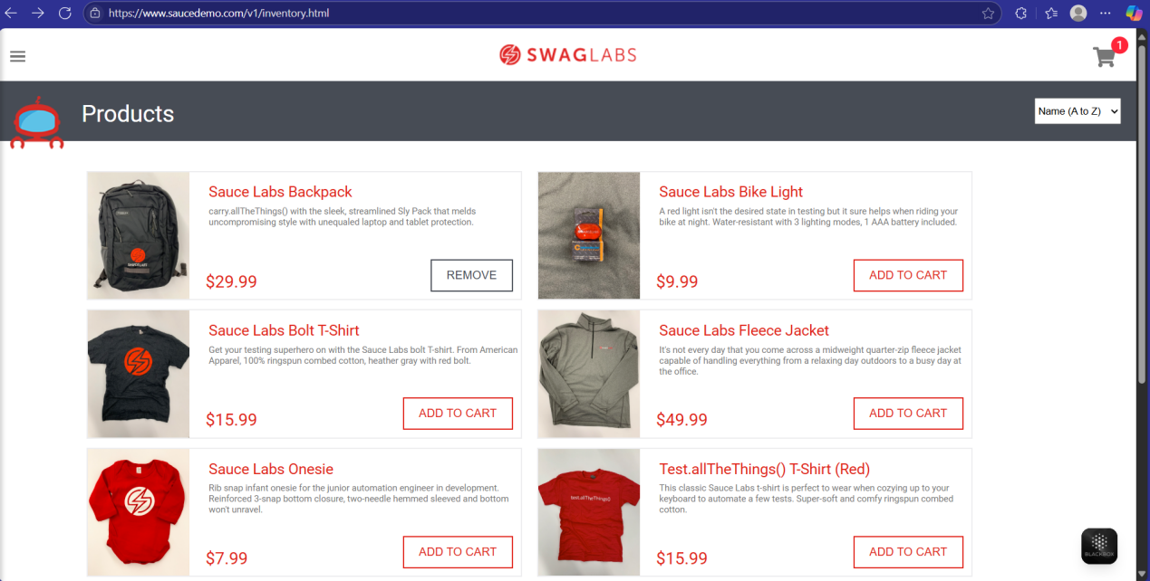

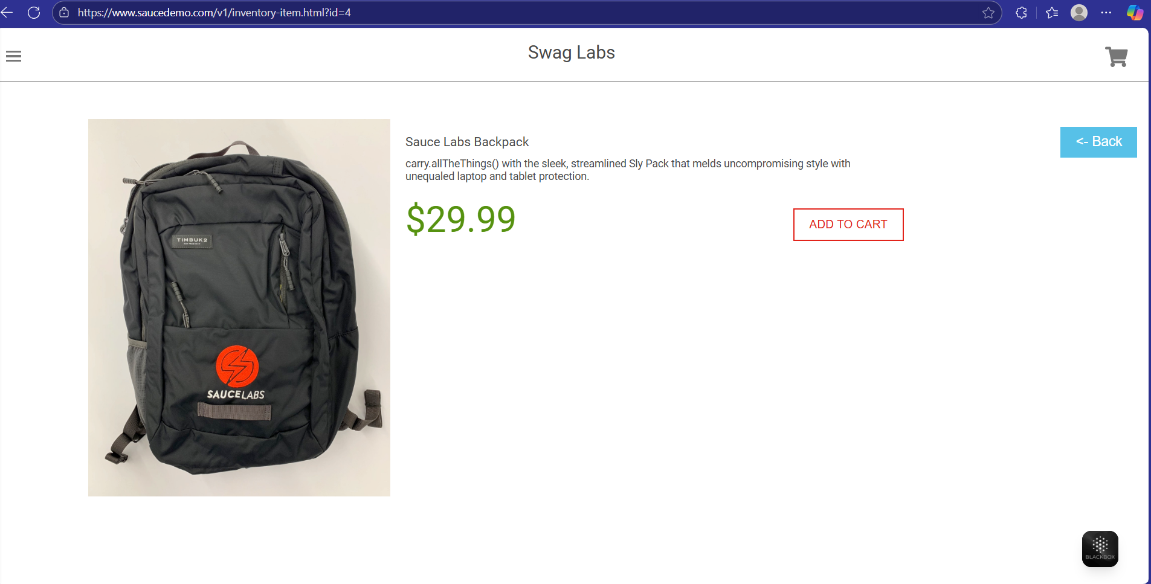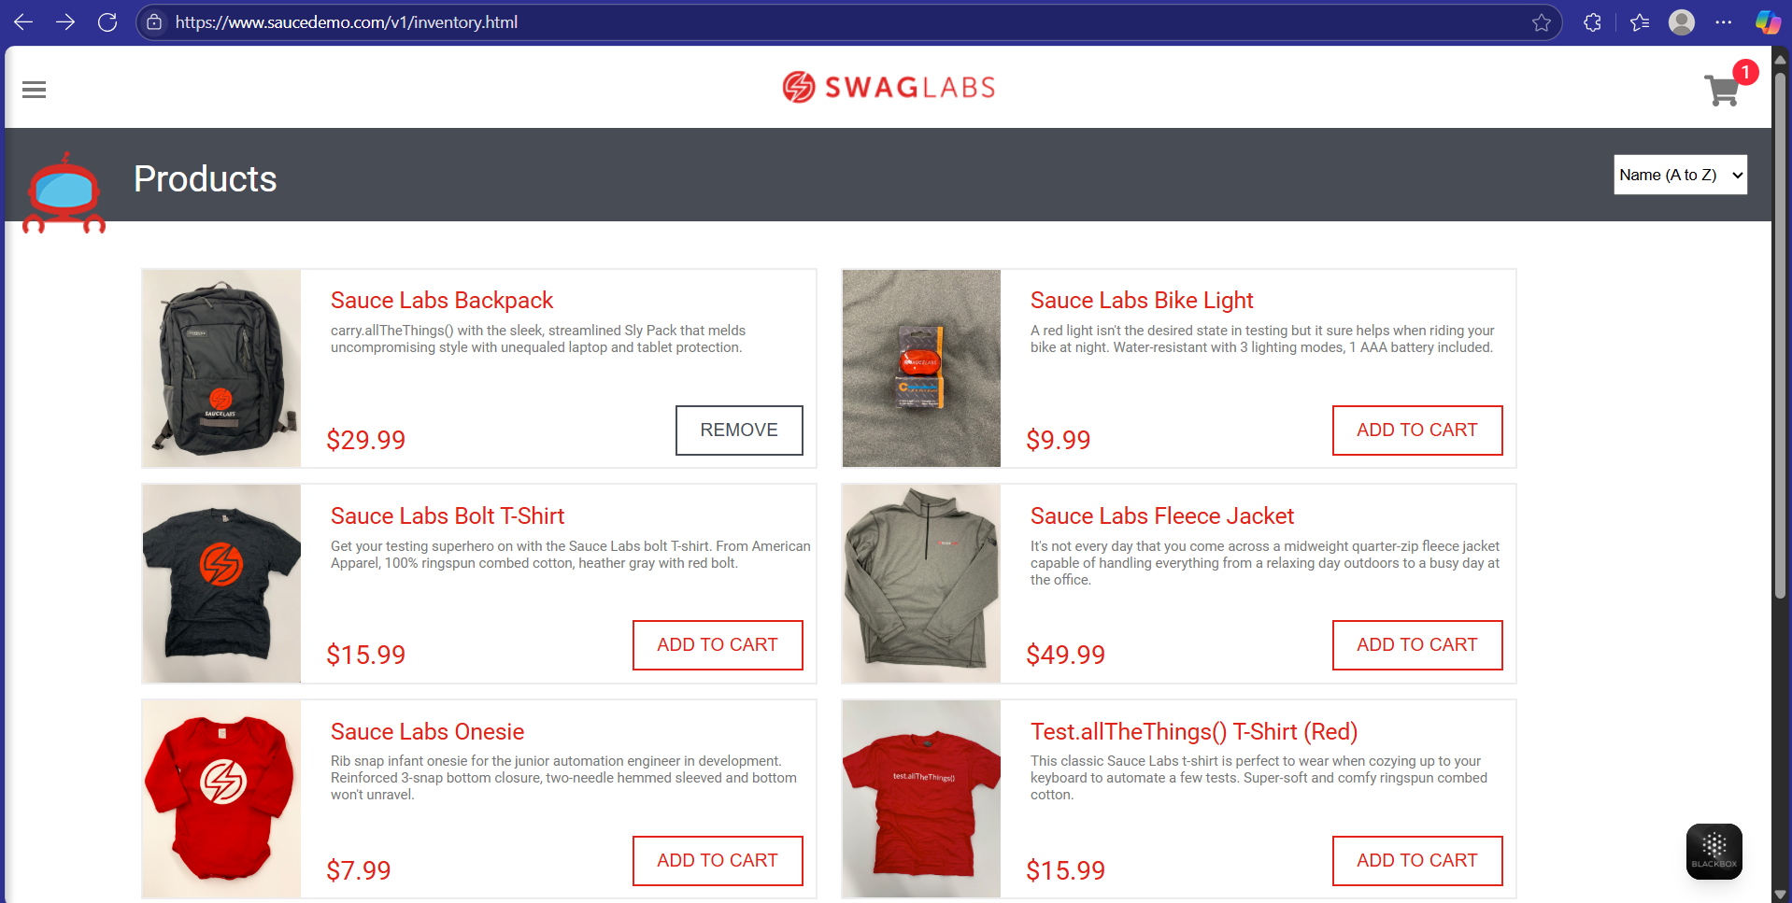

**Bug ID:** BUG-006

**Title:** The Cart icon counter not updating correctly across all pages

**Description**: When I add or removes products from the **Product Details** page the cart icon counter does not update consistently across The products page This causes incorrect cart item count display, leading to confusion for the user about the actual number of items in the cart.

**Steps:**

1- open url : "<https://www.saucedemo.com/v1/>"

2- enter "standard_user" in username field

3- enter "secret_sauce" in password field

4- click on login btn

5- click on ADD TO CART btn in products page

6- click on another product in products page

7- click on ADD TO CART btn in product details page

8- Observe the cart icon counter on all pages

**Expected Result:** The cart icon counter value should be updated across all pages.

**Actual Result:** The cart icon counter shows an incorrect value compared to the actual items in the cart.

**Priority**: Meduim

**Severity**: Meduim  
---

**Screenshot/video:**

**<https://drive.google.com/file/d/1h8PZyaaWWs26khY8OvlfcowlV4Tsj41r/view?usp=sharing>**

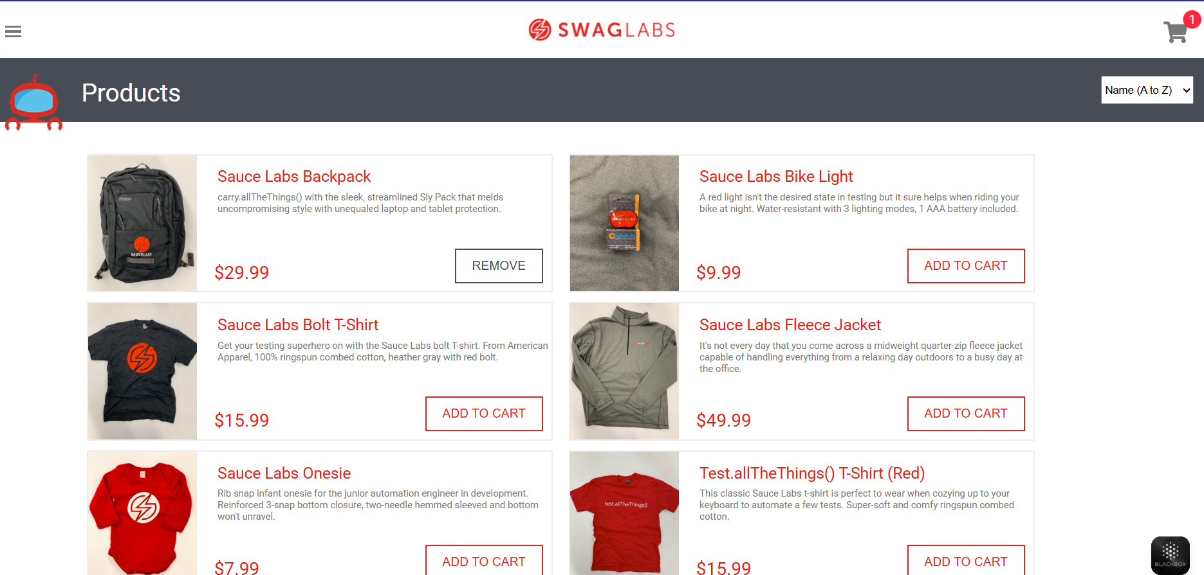

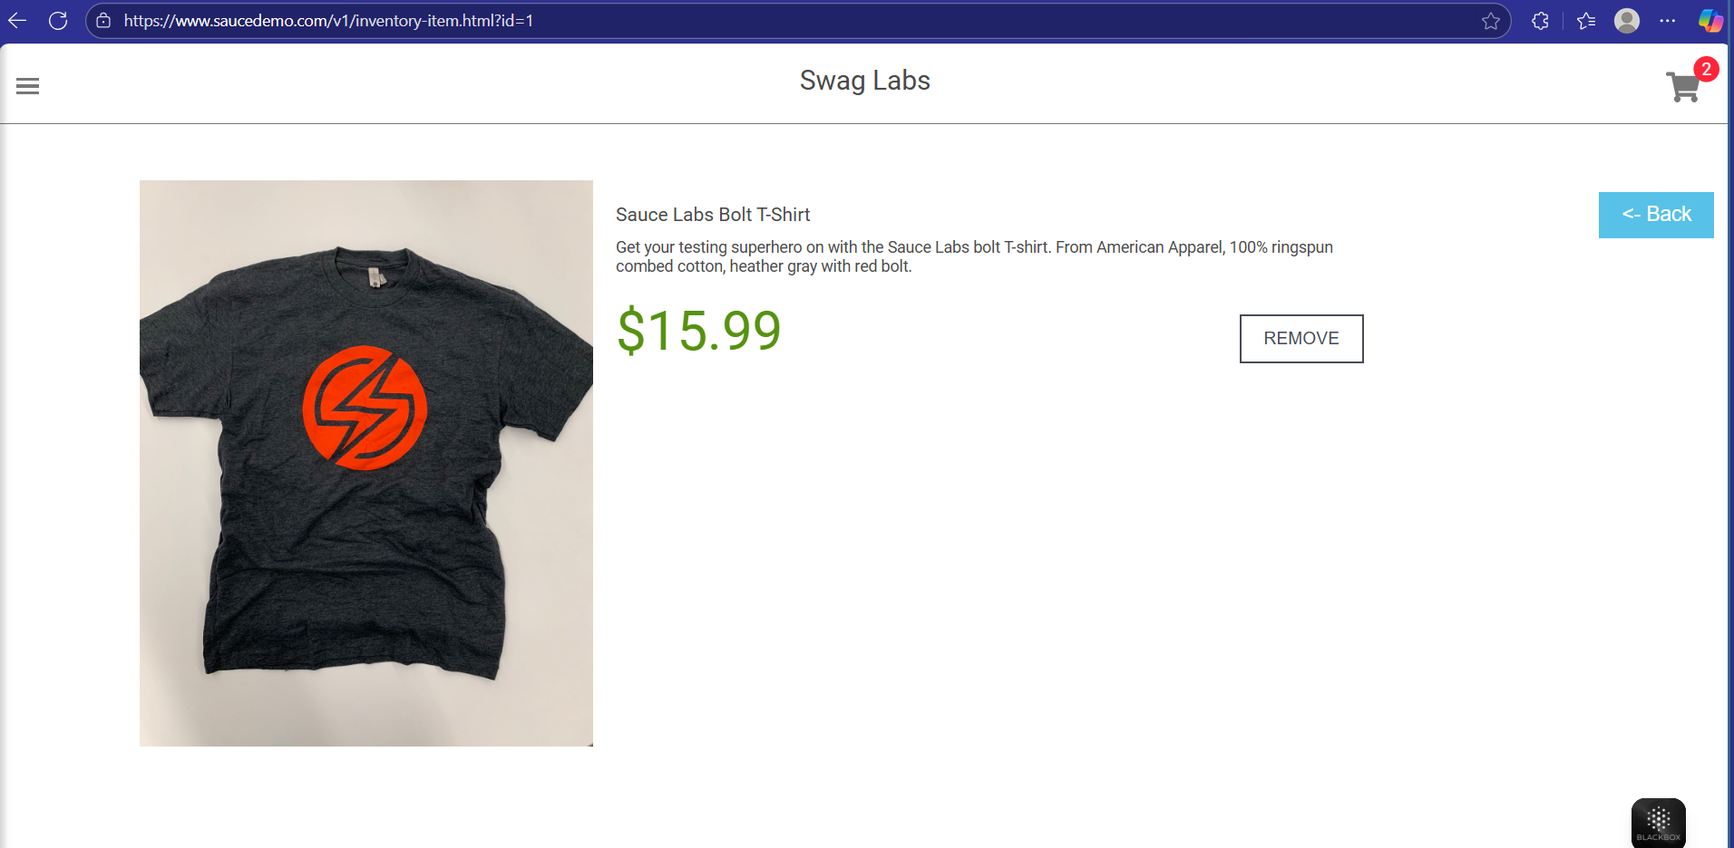

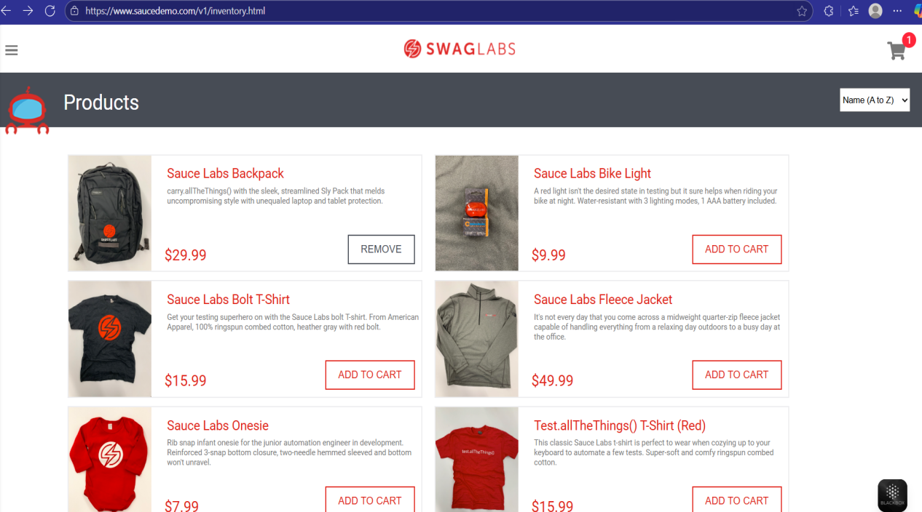

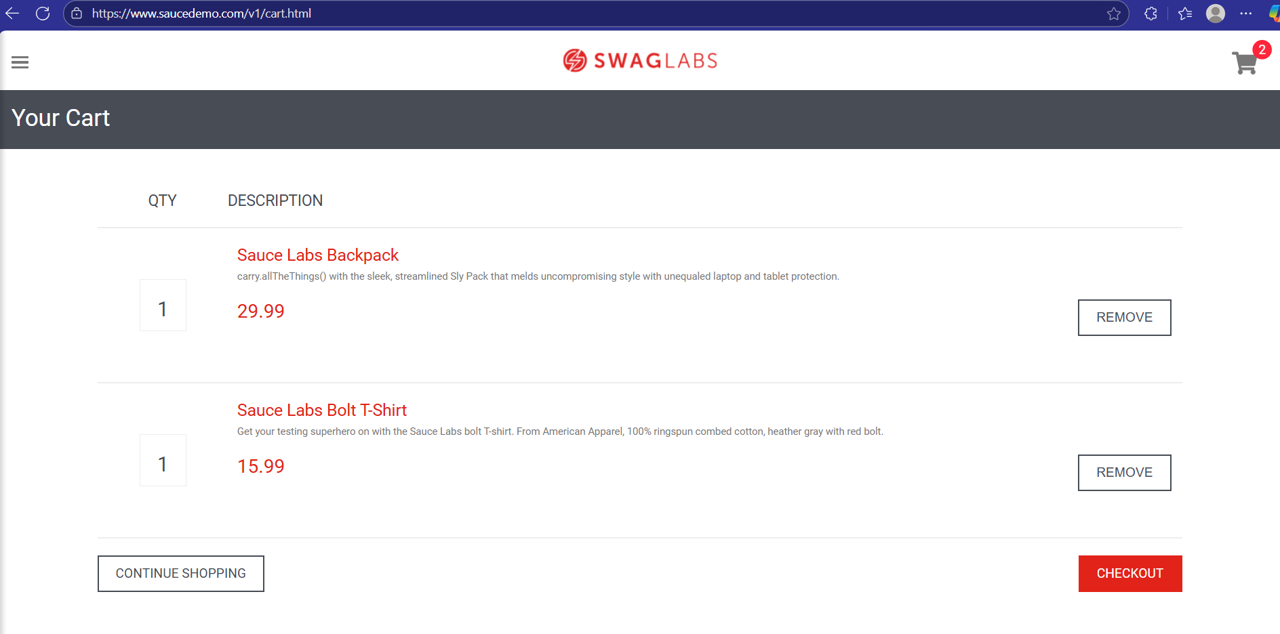

**Bug ID:** BUG-007

**Title:** the Product not added to cart when using problem_user account

**Description**: When logging in with the **problem_user** account and attempting to add a product to the cart from the Product Details page,some of products its cart functionality does not work as expected. The product is not added to the cart, the cart icon counter does not update, and the button label does not change to **REMOVE**.

**Steps:**

1- open url : "<https://www.saucedemo.com/v1/>"

2- enter "problem_user" in username field

3- enter "secret_sauce" in password field

4- click on login btn

5-click on a product in products page

6- click on ADD TO CART btn in product details page

**Expected Result:** the product will be added in cart page,

the cart icon counter increases by 1,

the button label should update from 'ADD TO CART' to 'REMOVE'.

**Actual Result:** The ADD TO CART btn in products details page to some products doesn`t work.

**Priority**: High

**Severity**: High  
---

**Screenshot/video:**

**<https://drive.google.com/file/d/1MJAd0Zl73OvHOr5eZw6oMDnBz2_Y8gh1/view?usp=sharing>**

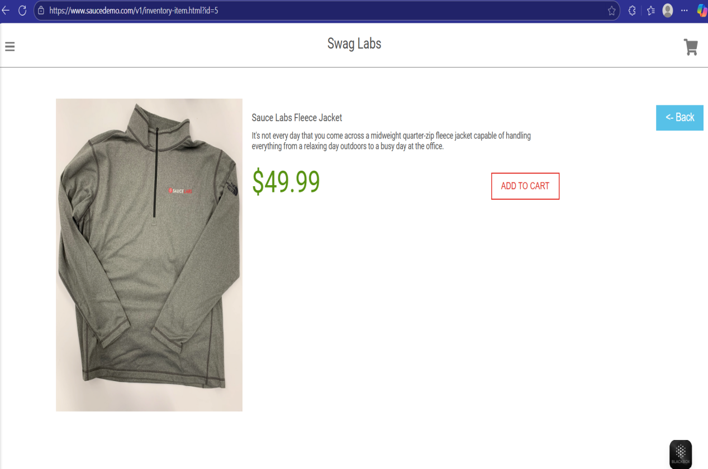

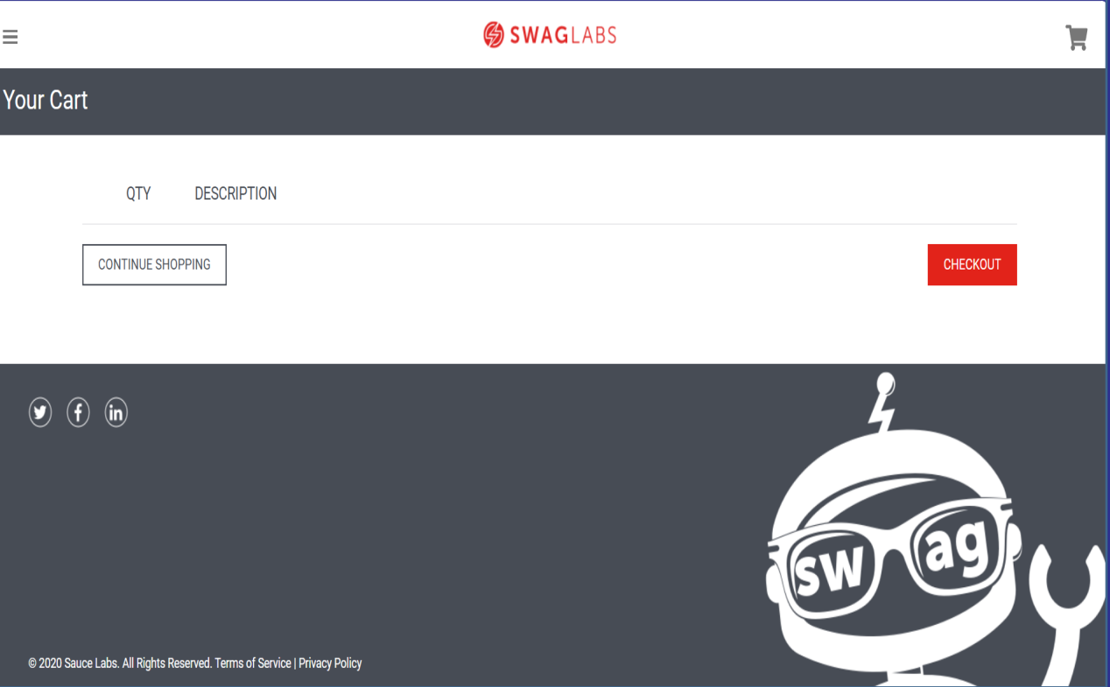

**Bug ID:** BUG-008

**Title:** The Product not removed from cart when using problem_user account

**Description**: When logging in with the **problem_user** account and attempting to remove a product from the Product Details page,cart functionality does not work as expected. The product is not removed from the cart, the cart icon counter does not decrease, and the button label does not change from **REMOVE** to **ADD TO CART**.

**Steps:**

1- open url : "<https://www.saucedemo.com/v1/>"

2- enter "problem_user" in username field

3- enter "secret_sauce" in password field

4- click on login btn

5-click on a product in products page

6- click on ADD TO CART btn in product details page

7- click on REMOVE btn in products details

**Expected Result:** the product will be removed from cart page,

the cart icon counter decrease by 1,

the button label should update from 'REMOVE' to 'ADD TO CART'.

**Actual Result:** The REMOVE btn in products details page doesn`t work.

**Priority**: High

**Severity**: High  
---

**Screenshot/video:**

**<https://drive.google.com/file/d/1eRSO37M5DIBTQcfGp5uXDvjxQ95zRj6J/view?usp=sharing>**

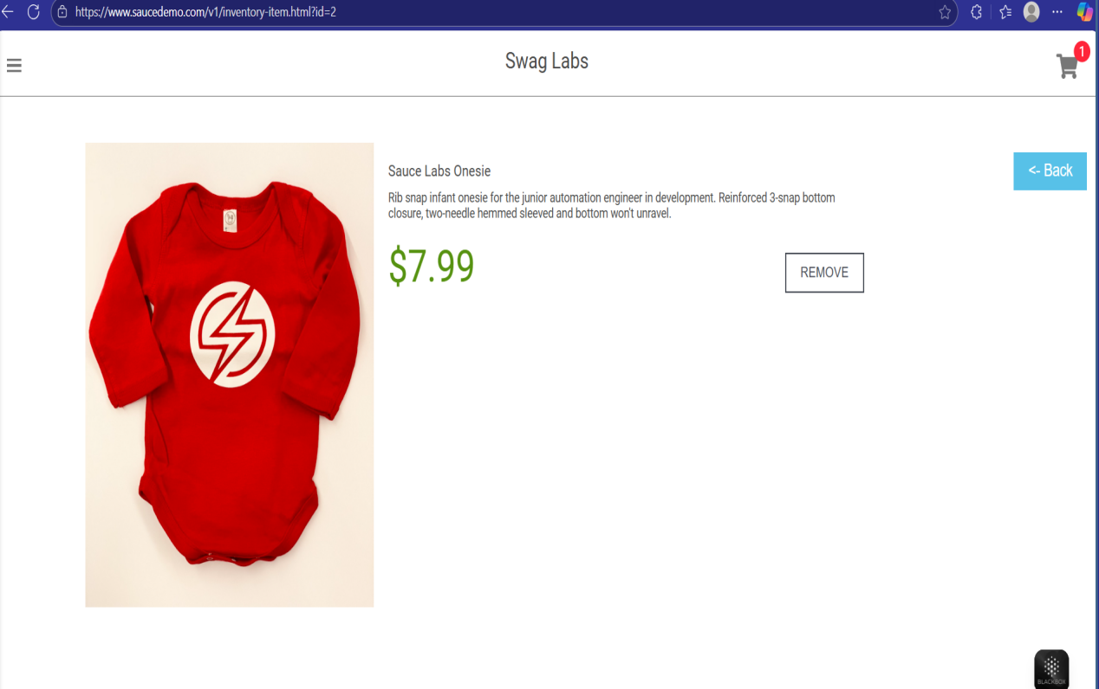

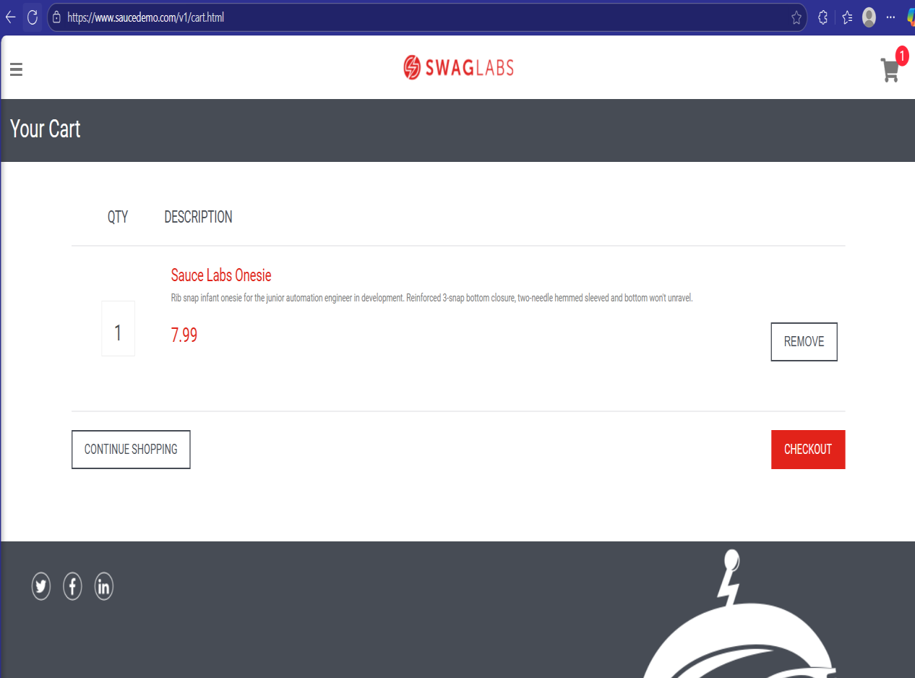

**Bug ID:** BUG-009

**Title:** The Checkout button is clickable when cart is empty.

**Description**: When the cart is empty, the **CHECKOUT** button should be disabled to prevent users from proceeding with an invalid checkout flow. However, the button remains clickable, allowing users to attempt checkout without any items in the cart.

**Steps:**

1- open url : "<https://www.saucedemo.com/v1/>"

2- enter "standard_user" in username field

3- enter "secret_sauce" in password field

4- click on login btn

5- open the cart page

6- click on CHECKOUT btn

**Expected Result:** The Checkout btn should be disabled.

**Actual Result:** The **CHECKOUT** button is still clickable even when the cart is empty.

**Priority**: High

**Severity**: High  
---

**Screenshot/video:**

**<https://drive.google.com/file/d/1PnWl0OTM4b5erCMNvBbVt5dZfF9LYXHJ/view?usp=sharing>**

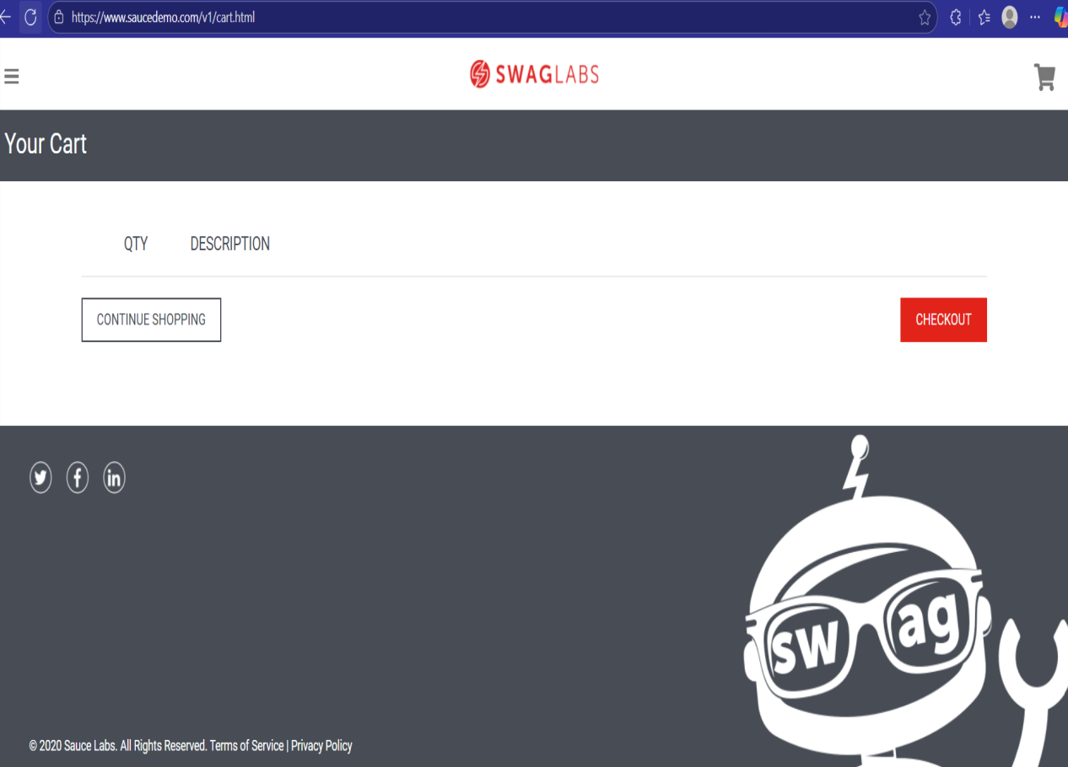

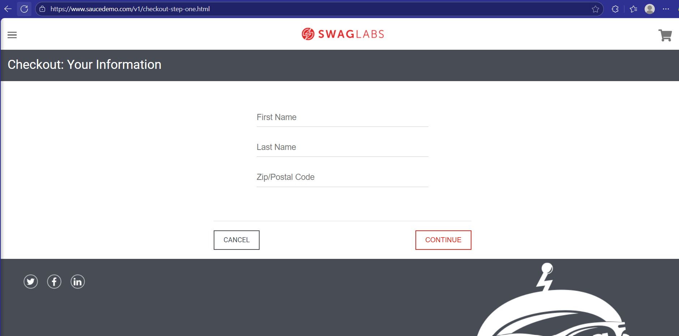

**Bug ID:** BUG-010

**Title:** The image of a product **isn**'t displayed in Cart page.

**Description**: When add a product to the cart and navigates to the **Cart** page, the image of a product is missing This issue affects the user’s ability to verify the product details before checkout.

**Steps:**

1- open url : "<https://www.saucedemo.com/v1/>"

2- enter "standard_user" in username field

3- enter "secret_sauce" in password field

4- click on login btn

5- click on ADD TO CART btn in products page

6- open the cart page

7- make sure that a product is viewed with its name, description, price, quantity, image

**Expected Result:** The product item should displayed successfully with its name,description, price, quantity, image in cart page.

**Actual Result:** The **image of a product isn**'t **displayed in cart page**.

**Priority**: low

**Severity**: low  
-----

**Screenshot/video:**

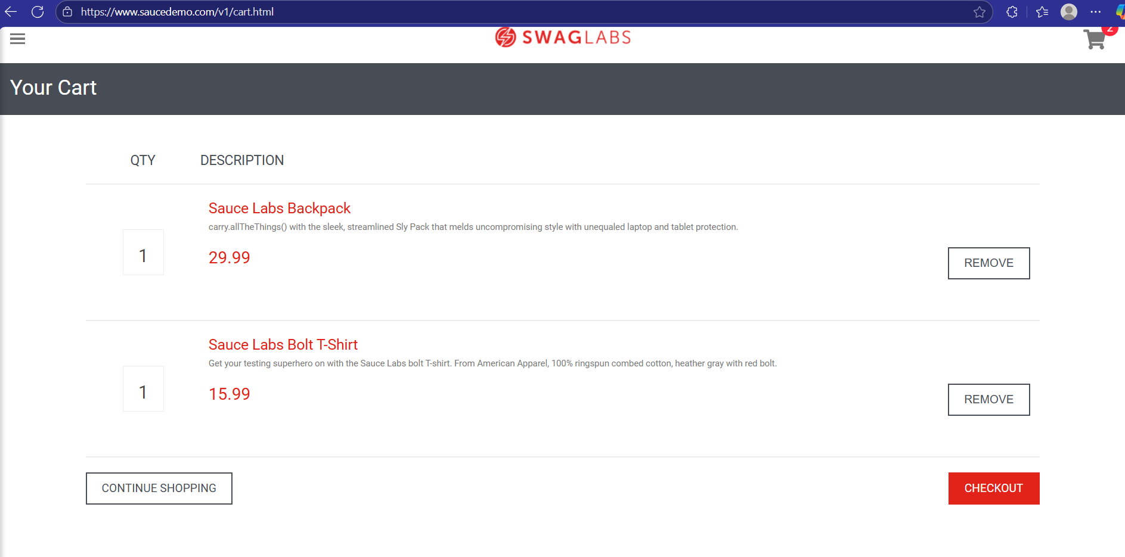

**Bug ID:** BUG-011

**Title:** The Total price not displayed in Cart page.

**Description**:When products are added to the cart, the **total price** **isn**'tdisplayed in the Cart page.

**Steps:**

1- open url : "<https://www.saucedemo.com/v1/>"

2- enter "standard_user" in username field

3- enter "secret_sauce" in password field

4- click on login btn

5- click on ADD TO CART btn to a product in products page

6- click on ADD TO CART btn to another product in products page

7- open the cart page

8- make sure that total price is displayed correctly

**Expected Result:** The total price should be available and correct.

**Actual Result:** The total price is not displayed **in cart page**.

**Priority**: Meduim

**Severity**: Meduim  
---

**Screenshot/video:**



**Bug ID:** BUG-012

**Title:** The Quantity field not displayed in Cart page.

**Description**:The **quantity field** is not visible. This prevents users from updating the number of item in the cart.

**Steps:**

1- open url : "<https://www.saucedemo.com/v1/>"

2- enter "standard_user" in username field

3- enter "secret_sauce" in password field

4- click on login btn

5- click on ADD TO CART btn to a product in products page

6- open the cart page

7- make sure that quantity field is displayed

**Expected Result:** The quantity field should be visible and selectable.

**Actual Result:** The quantity field is not displayed **in cart page**.

**Priority**: Meduim

**Severity**: Meduim  
------

**Screenshot/video:**



**Bug ID:** BUG-013

**Title:** There is delay on Continue Shopping btn for **performance_glitch_user**.

**Description**:When logging in with the **performance_glitch_user** account and clicking the **Continue Shopping** button in the Cart page, the navigation back to the Products page is delayed. Instead of redirecting immediately, which impacts user experience and indicates a performance issue.

**Steps:**

1- open url : "<https://www.saucedemo.com/v1/>"

2- enter "performance_glitch_user" in username field

3- enter "secret_sauce" in password field

4- click on login btn

5- click on ADD TO CART btn to a product in products page

6- open the cart page

7- click on Continue Shopping btn

**Expected Result:** I should be redirected back to the **Products** page **immediately** without any delay.

**Actual Result:** The navigation back to the Products page is **delayed**.

**Priority**: Meduim

**Severity**: Meduim  
---

**Screenshot/video:**

**<https://drive.google.com/file/d/13ohw3zUK9SL5j3xFJkkHnE2pfWd4ZaQv/view?usp=sharing>**